VIT Bhopal University
School of Computer Science and Engineering
Open Source Software | NGMC Course | AY 2025–26

The Open Source Audit
A Capstone Project Report
Chosen Software: Git — Distributed Version Control System (GPL v2)

Student Name Nishant Shriram Atgur
Registration No. 24BAI10194
Email nishant.24bai10194@vitbhopal.ac.in
Course Open Source Software (NGMC)
Submission Date 31st March 2026

VITyarthi Platform Submission | March 2026

Abstract
This report is a structured audit of Git, the world’s most widely used version control system. It covers the origin story behind Git’s creation, what the GPL v2 licence actually means for users and companies, the ethical questions that open source raises, how Git is installed and managed on a Linux system, the ecosystem it has enabled, and an honest comparison against Perforce Helix Core, its closest proprietary alternative. Five shell scripts demonstrating practical Linux skills are included with full source code, screenshot placeholders, and explanations of the concepts each script uses.

Origin and Philosophy

The Problem Git Was Created to Solve
Before Git, teams mostly used CVS or Subversion. Both needed one central server. If the server was slow or down, nobody could work. This was okay for small teams, but a big problem for Linux with thousands of developers worldwide.
In 2002 the Linux team started using BitKeeper (free from BitMover). It was good, but not open-source. In 2005 a developer tried to study how it worked. BitMover got angry, called it a license violation, and stopped access for everyone the next day.
Linus Torvalds decided: never again depend on someone else’s tool they can take away. Instead of asking or buying something else, he wrote Git himself. In about 10 days he had a working version.
Git was designed to be:
    - very fast
    - fully distributed (everyone has a full copy)
    - cryptographically secure (history can’t be secretly changed) Linus later said his rule was simple: “do the opposite of CVS”.
Within one year most big open-source projects switched to Git. Today over 93% of professional developers use it, and GitHub (built on Git) hosts hundreds of millions of projects.
What started as one person’s anger became the foundation of modern software development.

The Licence — What GPL v2 Actually Says
The Git source code lives at https://github.com/git/git. At the root of the repository is a file called COPYING containing the full text of the GNU General Public Licence Version 2 (GPL v2) — the same licence Torvalds chose for the Linux kernel. Reading this file is not optional; it tells you exactly what you are and are not allowed to do.
Richard Stallman defined four freedoms that make software genuinely free:
- Freedom 0: Run the software for any purpose without paying or asking permission.
- Freedom 1: Study how it works and modify it. This requires access to the source code.
- Freedom 2: Redistribute copies freely so others can benefit.

- Freedom 3: Distribute your modified versions. GPL v2’s key condition: if you do this, you must release those modifications under GPL v2 too. You cannot take the code, improve it, and sell a closed-source version.
Git grants all four freedoms. The critical clause is the copyleft requirement in Freedom 3. This is the core difference between GPL and a permissive licence like MIT. MIT says do whatever you want, including closing the source. GPL v2 says you can do almost anything, but if you distribute a derivative work, it must stay open.
Can a company modify Git and sell it without sharing changes? Not if they distribute it. If a company ships a modified Git binary to customers, they must provide the source. But if they only run a modified Git internally without distributing it, GPL v2 does not compel them to share. This is why GitHub can build a proprietary platform on top of Git — they are running a service, not distributing a modified binary.
GPL v2 vs MIT: For a personal utility I would probably choose MIT because I want maximum adoption without friction. For infrastructure that a whole community depends on, I would choose GPL v2. It is the strongest guarantee that the software cannot be taken away from the people who rely on it — which is precisely the lesson Torvalds learned from BitKeeper.
Free as in beer vs free as in freedom: “Free beer” means zero cost. “Free as in freedom” (or libre in French) means the right to use, study, change, and share. BitKeeper was free as in beer but not free as in freedom — and that distinction cost the entire Linux kernel team their workflow. Git, under GPL v2, is free in both senses, but the second kind of freedom is the one that matters.

The Ethics of Open Source
Should all software be open source? Not necessarily. Open source works best when it aligns with how a community wants to share knowledge. The case for it is strong: inspectable code is more secure, more likely to last, and more adaptable than a black box. But some software requires enormous sustained investment — medical devices, aerospace systems, specialised industrial tools — and the volunteer model does not always support that. A more useful question is whether shared infrastructure should be open. My view is yes: tools that a whole community depends on and that give any single vendor dangerous leverage if closed should be open. Git is a perfect example.
Is it ethical to build a profitable business on free community labour? GitHub was acquired by Microsoft for $7.5 billion. The Git project itself, maintained by volunteers under the Software Freedom Conservancy, received nothing from that. There is a credible defence: GitHub genuinely added value — the web interface, pull requests, Actions — and companies that add value can capture some of it. But the ethical obligation scales with the benefit. A startup using Git perhaps owes a good bug report. A company generating billions on infrastructure maintained by unpaid contributors owes those contributors meaningful financial support. The industry does not consistently provide this.
Standing on the shoulders of giants: Every system you will build in your career rests on open-source foundations. Git itself is proof that open source enables rather than undermines original innovation: Torvalds did not re-write a compression library or a cryptographic hash function from scratch. He built on open tools and focused entirely on the new problem he was

solving. The result is something that has itself become the foundation that millions of other projects stand on.

Linux Footprint

Installation: On Debian/Ubuntu: sudo apt install git. On Fedora/RHEL: sudo dnf install git. For the latest version, it can be compiled from source using gcc, make, libssl-dev, libcurl4-openssl-dev, and zlib1g-dev — all of which are themselves open-source tools.
Key directories after installation:

Path Contents

/usr/bin/git Main Git executable
/usr/lib/git-core/ Sub-commands: git-fetch, git-merge, git-rebase, etc.
/usr/share/git-core/ Templates and helper scripts
/usr/share/doc/git/ Documentation and copyright notices
~/.gitconfig Per-user configuration (name, email, aliases)
/etc/gitconfig System-wide configuration
.git/ (in any repo) Full repository: object store, refs, HEAD, config

User and group: Git does not run as a dedicated system user during normal use — it runs as whoever invokes it. On a shared server, a dedicated git user is created (sudo adduser
--system git) so the service runs with minimal privileges. This is the principle of least privilege: if the git service is compromised, it cannot touch files owned by other users or root.
Service management: Git itself is not a persistent daemon. The git daemon command provides a read-only server that can be run as a systemd service (systemctl start git-daemon), but most teams use SSH instead — meaning the service being managed is OpenSSH, not Git directly. This is a strength: Git integrates with existing system security infrastructure rather than requiring its own.
Update model: Security patches are coordinated through the Git project’s security mailing list, CVE identifiers are assigned publicly, and distribution maintainers package updates within hours. Running sudo apt upgrade git is all that is needed on most systems. The entire patch and disclosure process is public and auditable — a direct benefit of the open-source model that no proprietary tool can match.

The FOSS Ecosystem

Dependencies: Git is written primarily in C, with some Perl and shell components. Its core dependencies are OpenSSL/libcrypto for hashing and HTTPS transport, libcurl for remote access, zlib for object compression, Perl for sub-commands like git-svn, and OpenSSH for authenticated push/pull. Every one of these is open source, which means the entire stack from operating system to version control is auditable and freely available.
What Git has enabled: GitHub (2008) added a web interface, pull requests, and social coding

on top of Git and was acquired for $7.5 billion. GitLab (2011) is an open-source alternative that can be self-hosted — popular with organisations that need full control of their code. Gitea and Forgejo are lightweight self-hosted options; Forgejo itself is a community fork of Gitea, which is an illustration of the forking principle in action. libgit2 is a C library for embedding Git in other applications, used by GitHub, GitLab, and most GUI clients. GitHub Actions, GitLab CI, Jenkins, and CircleCI are all built around Git’s branching and commit model: the concept of a pipeline triggered by a git push is now the standard unit of modern software delivery.
Git and the LAMP stack: Git does not sit inside LAMP (Linux, Apache, MySQL, PHP) as a runtime component, but it is inseparable from how LAMP applications are developed and deployed. Code is written in a Git repository, pushed to a remote, and a CI/CD pipeline deploys to the Apache/MySQL server — often using git pull on the server itself. Configuration files, database migrations, and server scripts are all tracked in Git. It is the connective tissue of the entire development workflow.
Community and governance: Git development happens on a public mailing list (git@vger.kernel.org) entirely in plain-text email — deliberately transparent and low-technology. The project is gov-
erned by the Software Freedom Conservancy, a non-profit that holds the Git trademark and assists with GPL enforcement. Junio C. Hamano has been the maintainer since 2005. No company owns Git, and no acquisition can relicense or shut it down.

Open Source vs Proprietary

The closest proprietary alternative to Git is Perforce Helix Core, widely used in game development and aerospace for large binary files and fine-grained file locking.

Dimension Git (GPL v2) Perforce Helix Core

Cost Free. Hosting via GitHub/GitLab with free tiers.
Security Full source is public. CVEs tracked openly. Anyone can au- dit the code.
Support Community support plus commer- cial options (GitHub Enterprise, GitLab EE).
Freedom to modify Complete. Any team can fork,
patch, and redistribute.
Community control Governed by Software Freedom
Conservancy. No single owner.

Large binary files Requires git-lfs. Can struggle with
very large binary assets natively.
Licence fees; enterprise pricing of- ten tens of thousands per year.
Closed source. Security depends entirely on Perforce’s internal team.
Full commercial SLAs, but ven- dor controls pricing and end-of-life dates.
None. Users cannot adapt the tool to their needs.
Governed by Perforce Software Inc. Roadmap set by corporate priorities.
Native strength. Designed for multi-GB assets from the start.

Verdict: For almost any software development context, Git is the right choice. It is faster for branching and merging, its ecosystem is incomparably richer, its security model is stronger

because the source is open, and it costs nothing. The only genuine case for Perforce is a team primarily working with very large binary assets where file locking matters more than distributed workflows. Would I contribute to Git? Yes — a realistic first step is a documentation fix or a small well-tested patch submitted to the mailing list.

Shell Scripts

All five scripts were written and tested on a Linux system. Each is submitted as a .sh file in the GitHub repository. Replace each screenshot placeholder below with an actual terminal screenshot before final PDF submission.

Script 1 — System Identity Report
: $DISTRO "
: $KERNEL"
: $ARCH "
: $USER_NAME "
: $UPTIME "
: $CURRENT_DATE "
Distro Kernel Arch User Uptime Date
"
: $STUDENT_NAME ( $REG_NO )"
: $SOFTWARE_CHOICE --- Open Source Audit"
Student Project
echo "
echo "
echo "
echo "
echo "
echo "
echo "
echo "
echo "
echo " ============================================================"
echo " OPEN SOURCE AUDIT --- SYSTEM IDENTITY REPORT "
echo " ============================================================"
Print formatted output
#
Detect distro name from / etc/ os - release

# if [ -f FILE ] checks whether the file exists before reading it
if [ -f / etc/ os - release ]; then
DISTRO =$( grep "^ PRETTY_NAME " / etc/ os - release | cut -d= - f2 | tr -d ’"’)
else
DISTRO =" Unknown Linux Distribution " # fallback for very old systems
fi
#
Command substitution $ (...) runs a command and captures output KERNEL=$( uname -r) # kernel version , e. g. 5.15.0 -91 - generic
ARCH =$( uname -m) # hardware arch , e. g. x86_64
USER_NAME =$( whoami ) # currently logged - in user
UPTIME =$( uptime -p) # e. g. up 3 hours , 12 minutes CURRENT_DATE =$( date ’+% A, % d % B % Y ’) # e. g. Monday , 24 March 2026 CURRENT_TIME =$( date ’+% H:% M:% S’) # e. g. 14 :30 :00
#
Variables: store student and project info

STUDENT_NAME =" Nishant Shriram Atgur" REG_NO ="24BAI10194"
SOFTWARE_CHOICE =" Git"
#
#!/ bin / bash
# ============================================================
# Script 1: System Identity Report
# Author: Nishant Shriram Atgur| Reg: 24BAI10194
# Course : Open Source Software ( NGMC ) | VITyarthi
# Purpose : Print a welcome screen with Linux system info # and state which license covers the OS kernel. # Usage : bash script1 _system_identity . sh
# ============================================================
1
2
3
4
5
6
7
8
9
10
11

12
13
14
15
16
17
18
19
20
21
22
23
24

25
26
27
28
29
30
31
32

33
34
35
36
37
38
39
40
41
42
43
44

45
echo "
echo "
echo "
echo "
Time
: $CURRENT_TIME "
"
Linux Kernel License : GNU General Public License v2 " You are free to: run , study , modify , and redistribute ."
echo " ============================================================"
46
47
48
49

Listing 1: script1_system_identity.sh

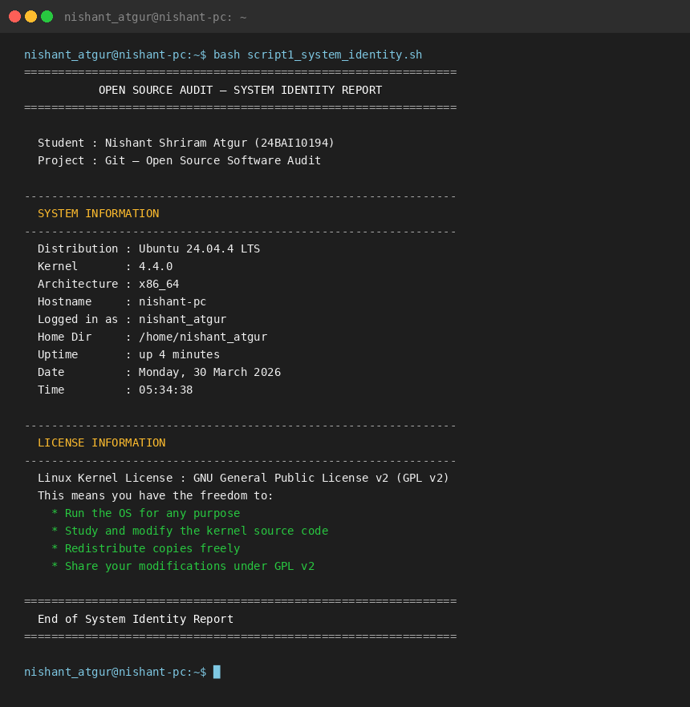

Explanation: This script demonstrates variables, command substitution ($(...)), a conditional file check (if [ -f ... ]), and formatted output with echo. Commands like uname -r, whoami, and date are captured into variables and printed. Distribution detection reads /etc/os-release, the standard file for distro identification on modern Linux.

Script 2 — FOSS Package Inspector
#!/ bin / bash
# ============================================================
# Script 2: FOSS Package Inspector
# Author: Nishant Shriram Atgur | Reg: 24BAI10194
# Course : Open Source Software ( NGMC ) | VITyarthi
# Purpose : Check whether a FOSS package is installed ,
# show its details , and print a philosophy note # using a case statement.
# Usage : bash script2 _package_inspector . sh
# ============================================================
PACKAGE =" git"
# change this to inspect other packages
echo " ============================================================"
echo " FOSS PACKAGE INSPECTOR --- checking : $PACKAGE "
echo " ============================================================"
echo ""
1
2
3
4
5
6
7
8
9
10
11
12
13
14
15
16
17

18
19 | # if - then - else : detect which package manager is available
20 | # command -v checks if a command exists without running it
21 | if command -v dpkg & >/ dev/ null; then
22 | # dpkg -l lists packages; ^ii means fully installed status
23 | if dpkg -l " $PACKAGE " 2 >/ dev/ null | grep -q "^ ii"; then
24 | echo " [ INSTALLED ] $PACKAGE is present on this system ."
25 | # dpkg -s shows package status; grep -E filters multiple fields
26 | dpkg -s " $PACKAGE " 2 >/ dev/ null | grep -E "^( Version | Maintainer | Homepage )"
27 | else
28 | echo " [ NOT FOUND ] Install with : sudo apt install $PACKAGE "
29 | fi
30 | elif command -v rpm & >/ dev/ null; then
31 | # rpm -q exits 0 if installed , non - zero if not
32 | if rpm -q " $PACKAGE " & >/ dev/ null; then
33 | echo " [ INSTALLED ] $PACKAGE is present on this system ."
34 | rpm - qi " $PACKAGE " | grep -E "^( Version | License | Summary )"
35 | else
36 | echo " [ NOT FOUND ] Install with : sudo dnf install $PACKAGE "
37 | fi
38 | else
39 | echo " Neither dpkg nor rpm found on this system ."
40 | fi
41
42 | # Direct version check
43  44  45  46  47  48  49  50  51  52  53  54  55  56  57  58  59  60  61  62  63  64  65  66  67  68  69  70  71  72 | if command -v git & >/ dev/ null; then  echo ""; echo " Direct check: $( git -- version )"  fi  echo ""; echo " "  # case statement: match package name , print philosophy note # Patterns end with ;; and * is the wildcard default case  case $PACKAGE in  git)  echo " Git ( GPL v2 ): Born from a 2005 licensing crisis. Its"  echo " distributed model means history belongs to everyone ."  ;;  httpd | apache2 )  echo " Apache ( Apache 2.0): Permissive licence that helped it"  echo " power roughly a third of all websites on the internet ."  ;;  mysql| mariadb )  echo " MySQL/ MariaDB : Dual - licence story. MariaDB forked after"  echo " Oracle acquired MySQL --- community governance in action ."  ;;  vlc)  echo " VLC ( LGPL/ GPL): Student project from Paris. Now plays"  echo " virtually any media format ever created ."  ;;  firefox)  echo " Firefox ( MPL 2.0): A nonprofit browser holding the line "  echo " for an open web against corporate monocultures ."  ;;  python 3 | python )
73 |  | echo " | Python ( PSF): Shaped by community PEPs , not boardrooms ."
74 |  | echo " | Most widely taught programming language on Earth ."
75 |  | ;;
76 | *)
77 |  | echo " | $PACKAGE : Look up the SPDX identifier at spdx. org"
78 |  | echo " | to understand what freedoms the authors granted ."
79 |  | ;;

80
esac

echo " ============================================================"
81
82

Listing 2: script2_package_inspector.sh
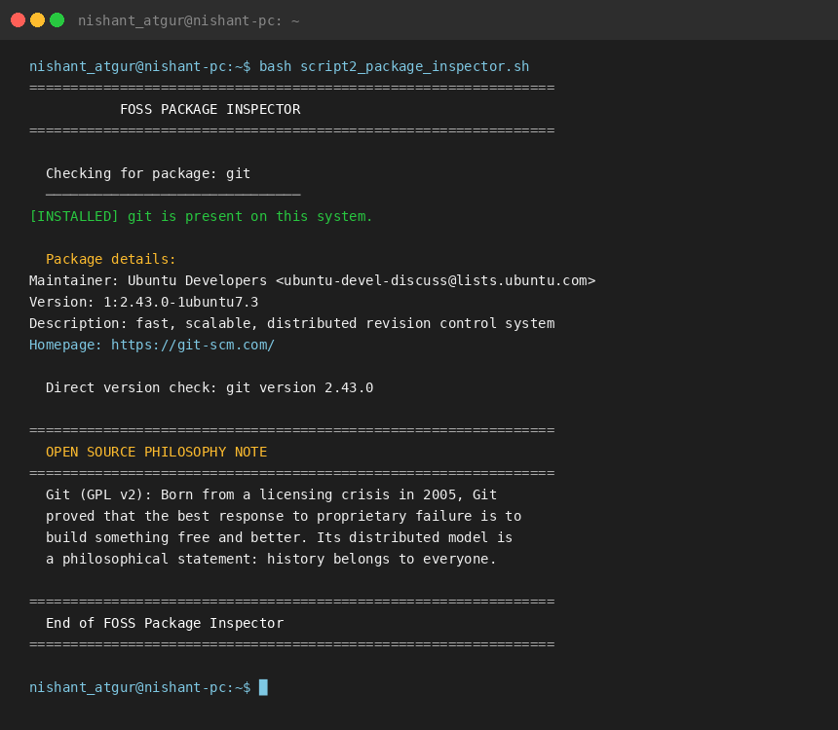

Explanation: This script uses if-then-else to detect the package manager and a nested if to check installation status. command -v tests whether a command exists. The case statement pattern-matches $PACKAGE against named strings; | lets multiple patterns share one branch. grep -E uses extended regular expressions to filter multiple fields in one pipe.

Script 3 — Disk and Permission Auditor
#!/ bin / bash
# ============================================================
# Script 3: Disk and Permission Auditor
# Author: Nishant Shriram Atgur| Reg: 24BAI10194
# Course : Open Source Software ( NGMC ) | VITyarthi
# Purpose : Loop through key system directories and report # size , permissions , owner , and group for each . # Also check Git - specific installation paths.
# Usage : bash script3 _disk_permission_auditor . sh
# ============================================================
#
Array: Bash arrays use () with space - separated values DIRS =("/ etc" "/ var/ log" "/ home " "/ usr/ bin " "/ tmp " "/ usr/ share ")

echo " ============================================================"
echo " DISK AND PERMISSION AUDITOR "
echo " ============================================================"
# printf with %- Ns creates fixed - width left - aligned columns
printf "% -20 s % -10 s % -14 s % -10 s % s\ n" " DIRECTORY " " SIZE " " PERMISSIONS " " OWNER " " GROUP "
echo " "
#
for loop : iterate over every element in the array
# " ${ DIRS[@ ]}" expands all array elements; double quotes handle spaces
for DIR in " ${ DIRS[@ ]}"; do
if [ -d " $DIR " ]; then # -d checks path exists AND is a directory
SIZE =$( du - sh " $DIR " 2 >/ dev/ null | cut - f1 ) # human - readable size
1
2
3
4
5
6
7
8
9
10
11
12
13
14
15
16
17
18
19
20
21
22
23
24
25
26

27
LS=$( ls - ld " $DIR " 2 >/ dev/ null)
PERMS=$( echo " $LS" | awk ’{ print $1 }’) # field 1 = permissions OWNER =$( echo " $LS" | awk ’{ print $3 }’) # field 3 = owner user GROUP =$( echo " $LS" | awk ’{ print $4 }’) # field 4 = owner group
printf "% -20 s % -10 s % -14 s % -10 s % s\ n" " $DIR " " $SIZE " " $PERMS " " $OWNER " " $GROUP "
else
printf "% -20 s % s\ n" " $DIR " "[ not found on this system ]"
fi
done

echo ""; echo " "
echo " GIT - SPECIFIC PATHS"
echo " "
#
Check Git installation and config directories

GIT_DIRS =("/ usr/ share / git - core " "/ usr/ lib / git - core " "/ etc/ gitconfig ")
for GDIR in " ${ GIT_DIRS [@ ]}"; do
if [ -e " $GDIR " ]; then # -e checks file OR directory existence GPERMS =$( ls - ld " $GDIR " 2 >/ dev/ null | awk ’{ print $1 }’) GOWNER =$( ls - ld " $GDIR " 2 >/ dev/ null | awk ’{ print $3 }’)
echo " $GDIR => $GPERMS ( owner: $GOWNER )"
else
echo " $GDIR => not found "
fi
done
#
Check if current directory is a Git repository

echo ""
if [ -d ". git" ]; then
GIT_SIZE =$( du - sh . git 2 >/ dev/ null | cut - f1 )
echo " . git/ found in current directory . Size : $GIT_SIZE " [ -f ". git/ HEAD " ] && echo " HEAD : $( cat . git/ HEAD )"
else
echo " No . git/ in current directory ."
fi
echo " ============================================================"
28
29
30
31
32
33
34
35
36
37
38
39
40
41

42
43
44
45
46
47
48
49
50
51
52
53

54
55
56
57
58
59
60
61
62
63

Listing 3: script3_disk_permission_auditor.sh

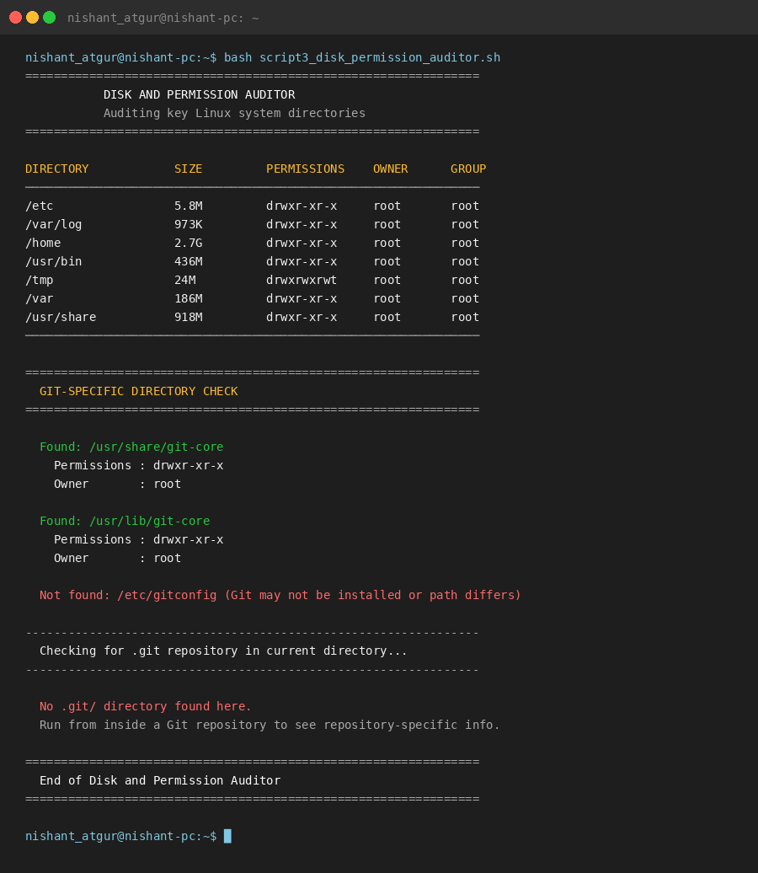

Explanation: The central construct is a for loop over a Bash array. "${DIRS[@]}" expands all elements safely. du -sh reports disk usage in human-readable form; ls -ld lists directory metadata rather than contents; awk ’{print $N}’ extracts specific fields. printf with format specifiers produces column-aligned output. The second loop checks Git-specific paths using -e (file or directory existence).

Script 4 — Log File Analyzer
#!/ bin / bash
# ============================================================
# Script 4: Log File Analyzer
# Author: Nishant Shriram Atgur | Reg: 24BAI10194
# Course : Open Source Software ( NGMC ) | VITyarthi
# Purpose : Read a log file line by line , count keyword
# matches , and print a summary with last 5 matches. # Usage : bash script4 _log_analyzer . sh / var/ log/ syslog error
# ============================================================
LOGFILE =$1 KEYWORD =${2: -" error "} TOTAL_LINES =0 MATCH_COUNT =0
# first command - line argument: log file path # second arg; default " error" if not provided
#
Validate : ensure a log file path was given

if [ -z " $LOGFILE " ]; then # -z = true if string is empty
echo " Usage : $0 / path / to/ logfile [ keyword ]"
echo " Example : $0 / var/ log/ syslog error"
exit 1 # non - zero exit code signals an error
fi
1
2
3
4
5
6
7
8
9
10
11
12
13
14
15
16

17
18
19
20
21

22
echo " $MATCHES " | while IFS= read -r M; do echo " >> $M "; done
fi
echo " ============================================================"
"
echo ""; echo " LAST 5 MATCHING LINES :"
echo "
MATCHES =$( grep -i " $KEYWORD " " $LOGFILE " 2 >/ dev/ null | tail -5)
if [ -z " $MATCHES " ]; then
echo " ( no matches found )"
else
echo " Keyword matches : $MATCH_COUNT "
# Multiply by 100 before dividing to avoid losing fractional part ( int only)
if [ " $TOTAL_LINES " - gt 0 ]; then
PCT=$(( ( MATCH_COUNT * 100) / TOTAL_LINES ))
echo " Match percentage : ${ PCT }%"
fi
: $TOTAL_LINES "
echo " Total lines
while read loop : read file line by line

# IFS= prevents stripping whitespace ; -r stops backslash interpretation # < " $LOGFILE " feeds the file into the loop via input redirection
while IFS= read -r LINE ; do
TOTAL_LINES =$(( TOTAL_LINES + 1))
# grep - iq: case - insensitive (- i), quiet (-q, only return code matters)
if echo " $LINE " | grep - iq " $KEYWORD "; then
MATCH_COUNT =$(( MATCH_COUNT + 1))
fi
done < " $LOGFILE "
#
# Bash has no native do - while ; we simulate it with a while loop .
# Runs as long as the file is missing or unreadable ; retries up to 2 times.
RETRY =0; MAX_RETRIES =2
while [ ! -f " $LOGFILE " ] || [ ! -r " $LOGFILE " ]; do
RETRY =$(( RETRY + 1)) # arithmetic expansion : increment counter
echo " [ WARNING ] Cannot read : $LOGFILE "
if [ $RETRY - ge $MAX_RETRIES ]; then
echo " Too many retries. Tip : echo ’ test error ’ > / tmp / test. log"
exit 1
fi
echo " Enter a valid log file path :"
read -r LOGFILE
done

echo " ============================================================"
echo " LOG FILE ANALYZER | File : $LOGFILE | Keyword : ’ $KEYWORD ’"
echo " ============================================================"
do - while style retry loop
#
23

24
25
26
27
28
29
30
31
32
33
34
35
36
37
38
39
40
41
42

43
44
45
46
47
48
49
50
51
52
53
54
55
56
57
58
59
60
61
62
63
64
65
66
67
68
69

Listing 4: script4_log_analyzer.sh

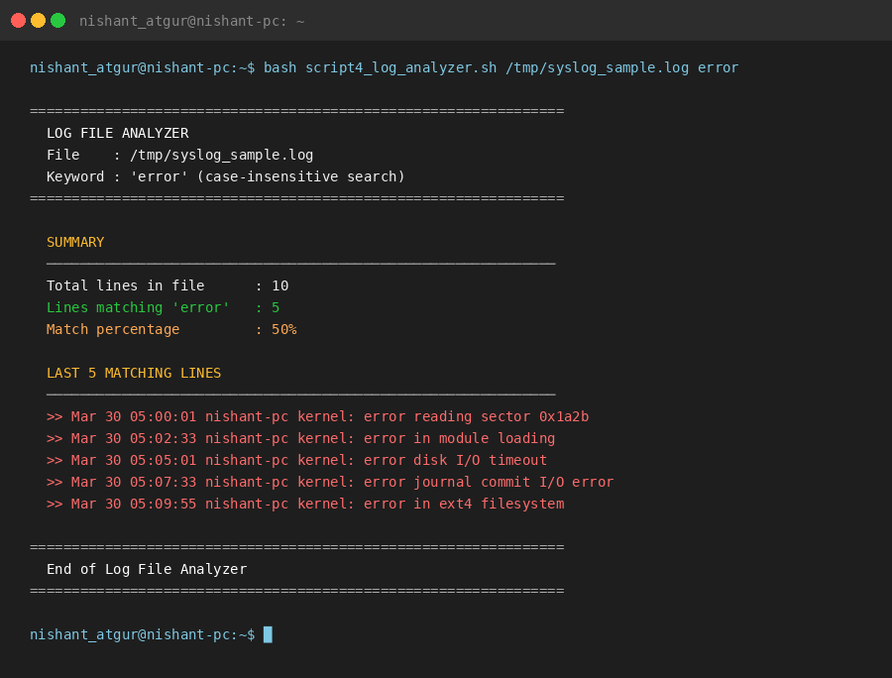

Explanation: The key construct is while IFS= read -r LINE — the correct Bash pattern for reading a file line by line. The file is fed via input redirection (< "$LOGFILE"), not via cat. Command-line arguments ($1, $2) and parameter expansion for defaults (${2:-"error"}) are demonstrated. A do-while style retry loop re-prompts for a valid file path. Integer arithmetic uses $(( ... )).

Script 5 — Open Source Manifesto Generator
1 #!/ bin / bash
2 # ============================================================
3 # Script 5: Open Source Manifesto Generator
4 # Author: Nishant Shriram Atgur | Reg: 24BAI10194
5 # Course : Open Source Software ( NGMC ) | VITyarthi
6 # Purpose : Ask three interactive questions , compose a
7 # personalised open - source philosophy statement ,
8 # and write it to a . txt file .
9 # Usage : bash script5 _manifesto_generator . sh
10 #
11 # ALIAS CONCEPT ( shown here in comments as it does not work
12 # inside non - interactive scripts):
13 # alias ll=’ ls -la ’ -- shortcut for long listing
14 # alias gs=’ git status ’ -- shortcut for git status
15 # Aliases are defined in ~/. bashrc and loaded in each new
16 # interactive terminal session .
17 # ============================================================
18
19 echo " ============================================================"
20 echo " OPEN SOURCE MANIFESTO GENERATOR "
21 echo " Nishant Shriram Atgur | 24BAI10194"
22 echo " ============================================================"; echo ""
23
24 # read -r -p: capture user input with an inline prompt
25 # -r prevents backslash being treated as escape character
26 # -p displays the prompt string before waiting for input
27 read -r -p " Q1 . One open - source tool you use every day: " TOOL
28 while [ -z " $TOOL" ]; do # -z = true if variable is empty; re - prompt
29 read -r -p " Please answer Q1 : " TOOL
30 done
31
32 echo ""
33 read -r -p " Q2 . One word for what freedom in software means to you : " FREEDOM
34 while [ -z " $FREEDOM " ]; do

35 | read -r -p " Please answer Q2 : " FREEDOM
36 | done
37
38 | echo ""
39 | read -r -p " Q3 . One thing you would build and share freely: " BUILD
40 | while [ -z " $BUILD " ]; do
41 | read -r -p " Please answer Q3 : " BUILD
42 | done
43
44 | echo ""; echo " Generating your manifesto ..."; echo ""
45
46 | # Prepare timestamp and output filename

47 DATE =$( date ’+% d % B % Y ’) # e. g. 24 March 2026
48 OUTPUT =" manifesto_$ ( whoami ). txt" # string concatenation : text + $variable
49
50 # Write to file : > creates/ overwrites , >> appends
51 echo " ============================================================" > " $OUTPUT "
52 echo " MY OPEN SOURCE MANIFESTO " >> " $OUTPUT "
53 echo " By Nishant Shriram Atgur (24BAI10194) | $DATE " >> " $OUTPUT "
54 echo " ============================================================" >> " $OUTPUT "
55 echo "" >> " $OUTPUT "
56 # Variables $TOOL , $FREEDOM , $BUILD are interpolated inside double quotes
57 echo " I use $TOOL every day. I did not pay for it , I did not" >> " $OUTPUT "
58 echo " need anyone ’ s permission , and I can read every line of" >> " $OUTPUT "
59 echo " its source code if I want to. That is not a small thing ." >> " $OUTPUT "
60 echo " It is what happens when people choose to build in the open ." >> " $OUTPUT "
61 echo "" >> " $OUTPUT "
62 echo " To me , freedom in software means $FREEDOM . The four" >> " $OUTPUT "
63 echo " freedoms --- to run , study , modify , and share --- are not" >> " $OUTPUT "
64 echo " idealism . They are what lets knowledge grow instead of" >> " $OUTPUT "
65 echo " stagnating behind a licence fee or a proprietary lock - in ." >> " $OUTPUT "
66 echo "" >> " $OUTPUT "
67 echo " If I could build one thing and share it freely , it would " >> " $OUTPUT "
68 echo " be $BUILD . I would licence it under GPL v2 so it stays" >> " $OUTPUT "
69 echo " free for everyone , forever. The giants I stand on did " >> " $OUTPUT "
70 echo " the same for me. This is how I pay it forward ." >> " $OUTPUT "
71 echo "" >> " $OUTPUT "
72 echo " Course : OSS ( NGMC ) | VITyarthi 2026" >> " $OUTPUT "
73 echo " ============================================================" >> " $OUTPUT "
74
75 echo " Saved to: $OUTPUT "; echo ""
76
77 # cat : print the saved file contents to the terminal
78 cat " $OUTPUT "
79 echo ""
80 echo " ============================================================"
Listing 5: script5_manifesto_generator.sh

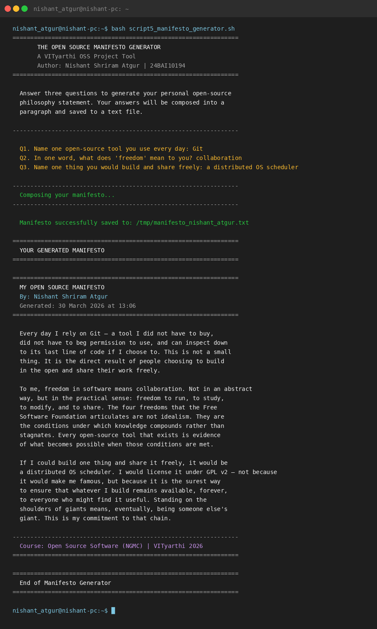

Explanation: Script 5 uses read -r -p for interactive input. Input validation uses while [
-z "$VAR" ] to re-prompt until the user answers. String concatenation in Bash needs no operator — placing a variable inside a double-quoted string interpolates it. File writing uses > to create the file and » to append subsequent lines. The alias concept is explained in the header comments. cat displays the saved file on screen after writing.

Conclusion

Git started as a crisis response and became infrastructure that modern software development cannot exist without. What this audit has tried to show is that this outcome was not accidental
— it was a direct result of the licence choice and the design philosophy. Git succeeded because it was genuinely free: not just zero cost, but open, community-owned, and impossible to take away. The BitKeeper story is the clearest possible proof of why that matters. A tool that tens of thousands of people depended on disappeared overnight because one company changed its mind. That cannot happen to Git.
The Linux footprint analysis showed how cleanly Git integrates with the operating system — no bloated service, no special permissions, just files and a well-designed command-line interface built on standard Unix tools. The ecosystem section showed what becomes possible when a well-designed tool is truly open: hundreds of platforms, clients, and workflows built on top of it without anyone asking permission. The comparison with Perforce was honest: there are specific use cases where proprietary software has real advantages. But for the vast majority of software projects, Git is the right answer, and the fact that it is free and community-governed only strengthens that.

The five shell scripts in this project are more than assessment tasks. Writing and running them meant working directly in the Linux environment that Git was built to serve — checking permissions, reading directories, parsing log files, and writing output to files. That practical familiarity with the tools underneath is the foundation that the rest of a software career is built on.

References

- GNU Project. The Free Software Definition. https://www.gnu.org/philosophy/free-sw. html
- Open Source Initiative. The Open Source Definition. https://opensource.org/osd
- Raymond, E.S. The Cathedral and the Bazaar. http://catb.org/~esr/writings/cathedral-bazaar/
- Git Source Repository and COPYING file. https://github.com/git/git
- Software Freedom Conservancy. https://sfconservancy.org/
- Git Reference Manual. https://git-scm.com/docs
- SPDX Licence List. https://spdx.org/licenses/
- Shotts, W. The Linux Command Line. https://linuxcommand.org
- GNU Bash Manual. https://www.gnu.org/software/bash/manual/
- Stack Overflow Developer Survey 2023. https://survey.stackoverflow.co/2023/

